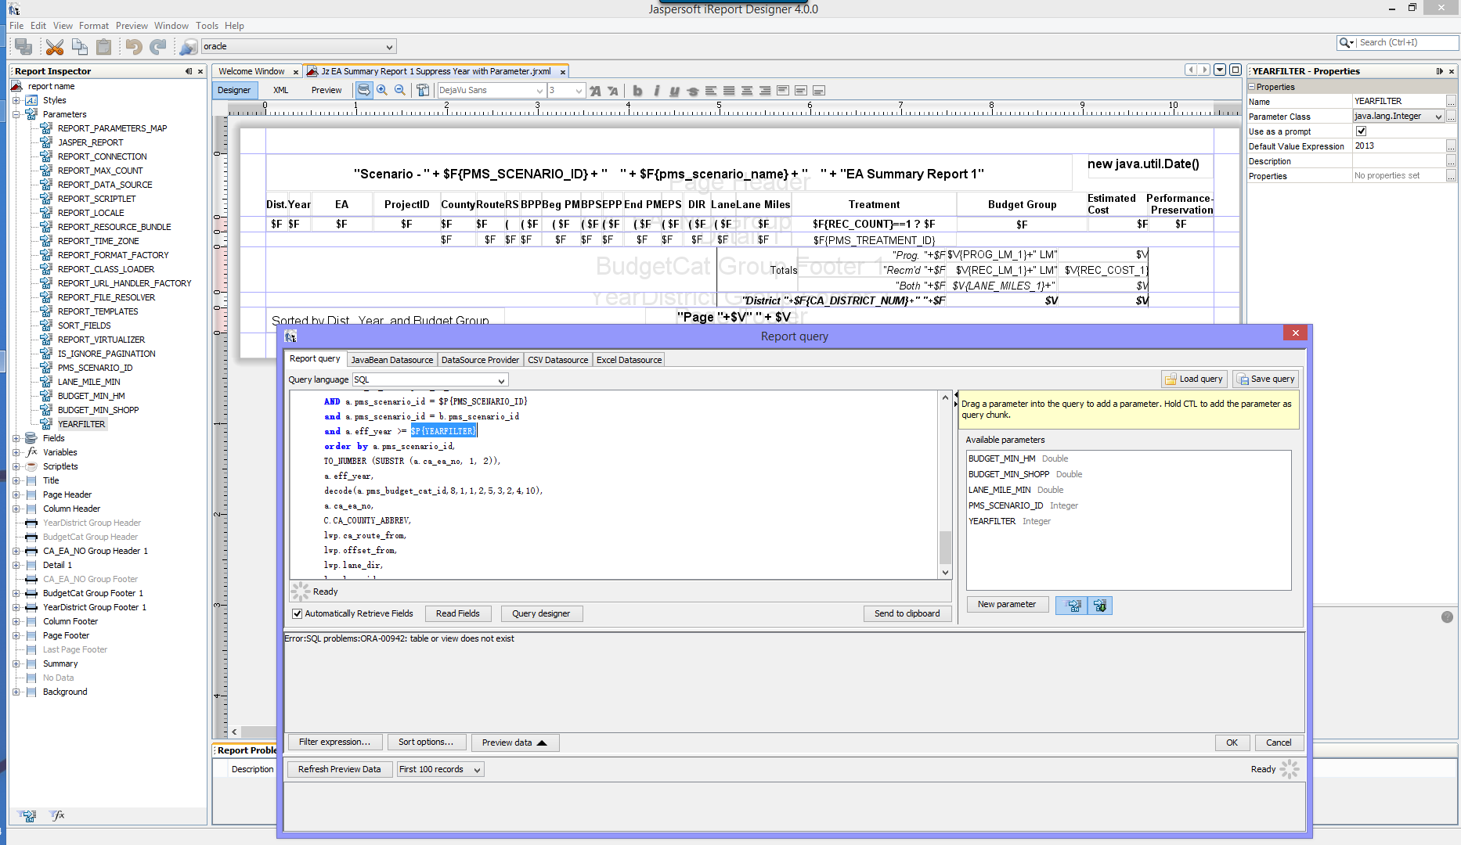

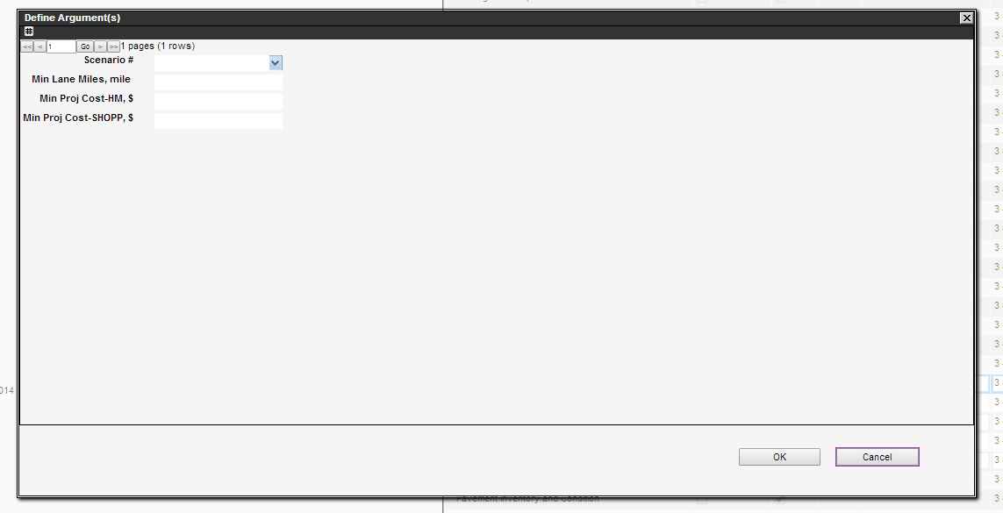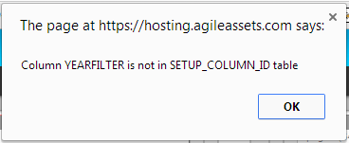 Similarly, I would like to add a parameter to filter the district.

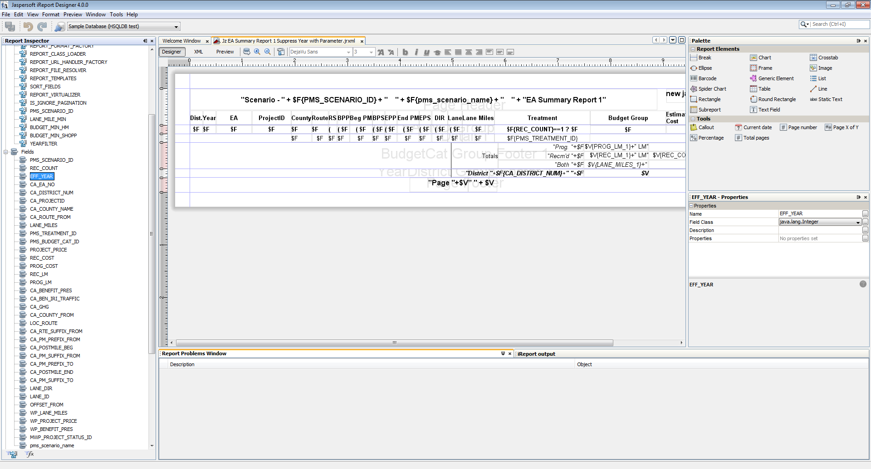

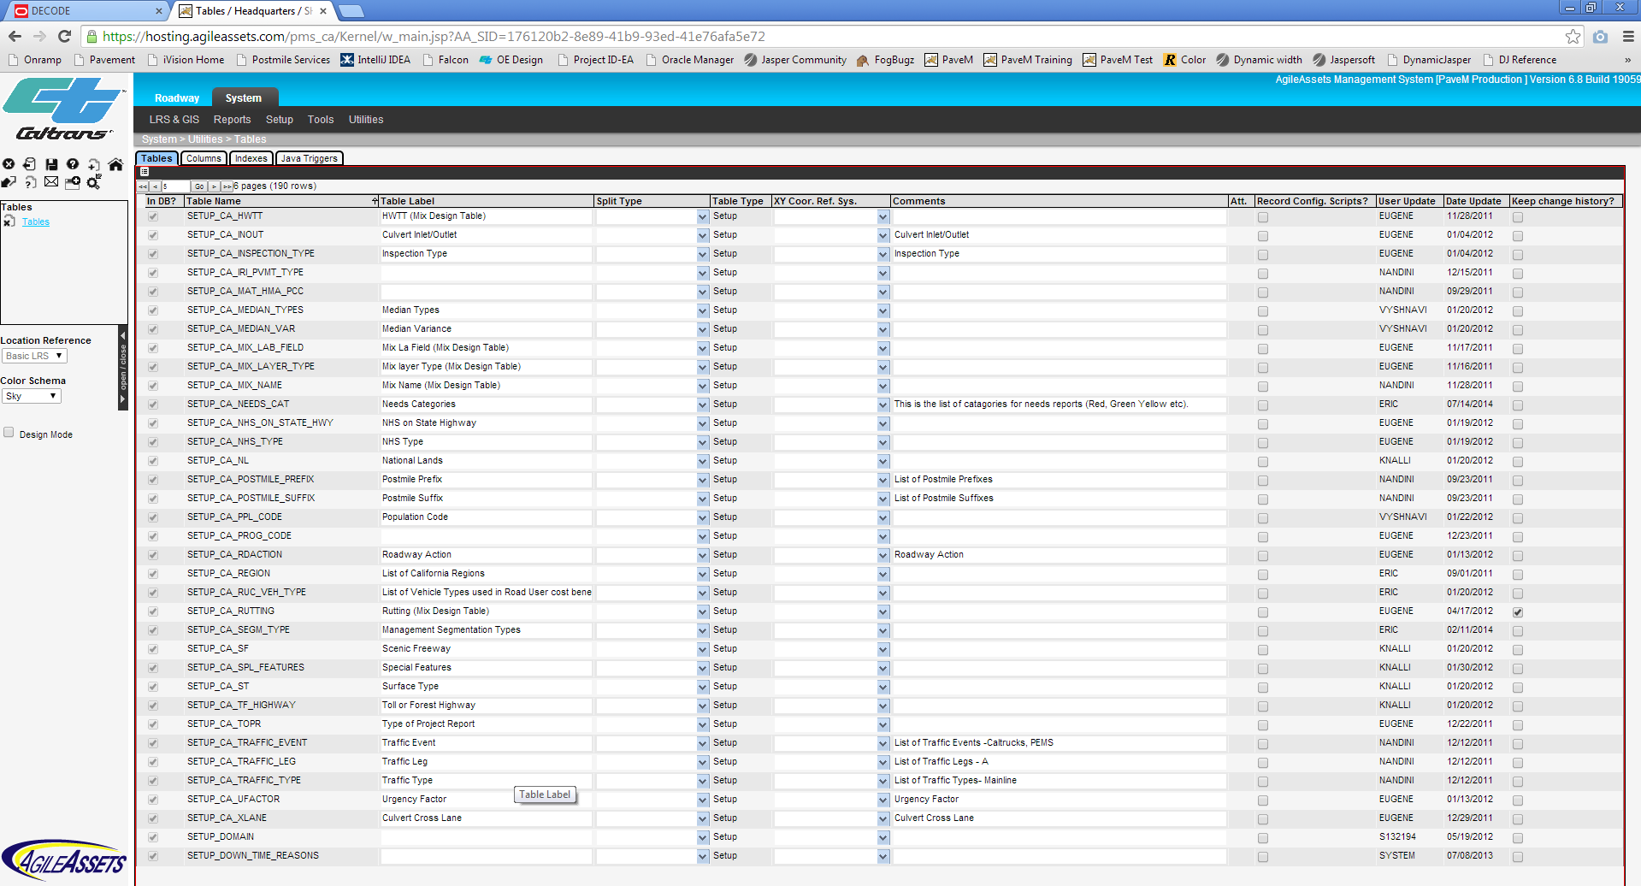

Can you give me the source code of all the classes you use in the Calculate Preservation Benefit Unscaled Groovy script?

Import ***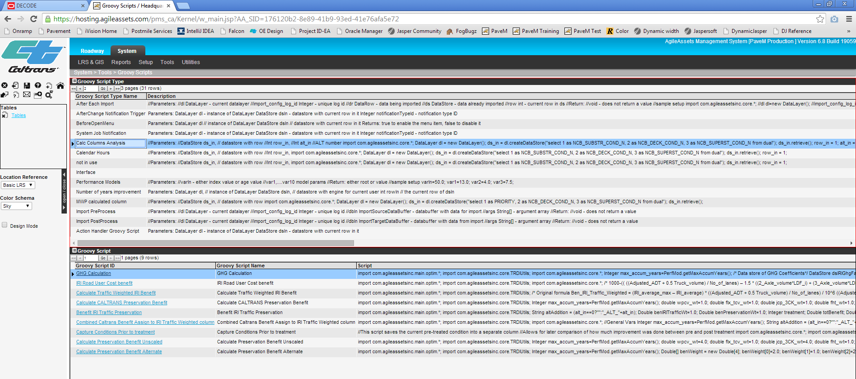

What does script setup mean? Does it mean we can put those codes to the main script?

What will happen if I modify the code here and then click the Parse or Run icon? 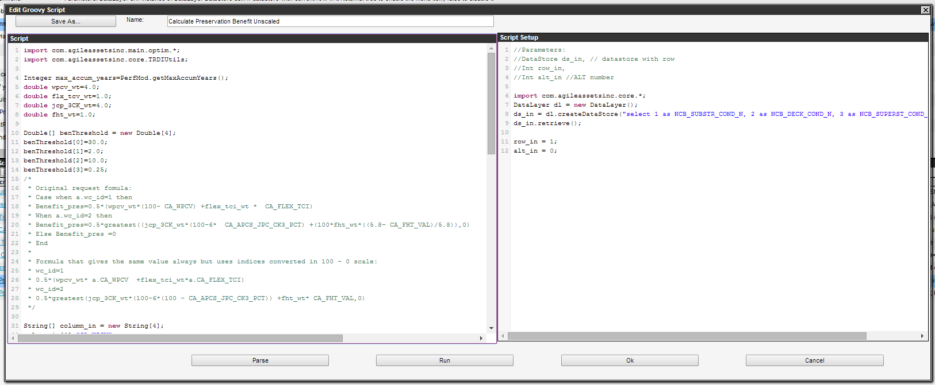

Why ““ ”” ? What kind of string is it? Why IntelliJIDE complains the last line of code?

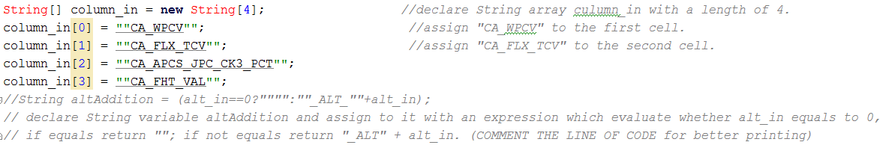

I know there are some manuals for trainers, users, and administrators.

Do you have a manual for developer, DBA/middleware unit?

Do you have a clean copy of the PaveM middleware? I would like to host PaveM in my own PC.

There are some tables/views is in the database but not showing in PaveM, like the view ca_ea_benefit_vw, and the table setup_loc_ident and the table setup_column_id.